Model Development Phase Template

|  |  |
| --- | --- |
| Date | 25 June 2025 |
| Team ID | SWTID1749974387 |
| Project Title | Neural Networks Ahoy: Cutting-edge Ship Classification for Maritime Mastery |
| Maximum Marks | 4 Marks |

**Initial Model Training Code, Model Validation and Evaluation Report**

The initial model training code will be showcased in the future through a screenshot. The model validation and evaluation report will include classification reports, accuracy, and confusion

matrices for multiple models, presented through respective screenshots.

**Initial Model Training Code:**

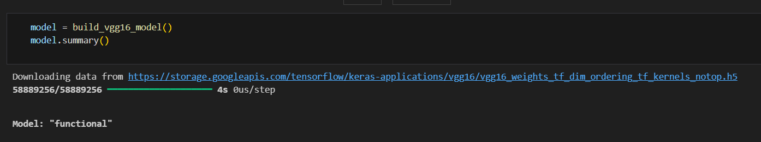

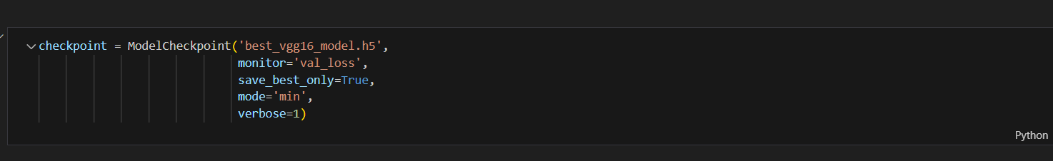

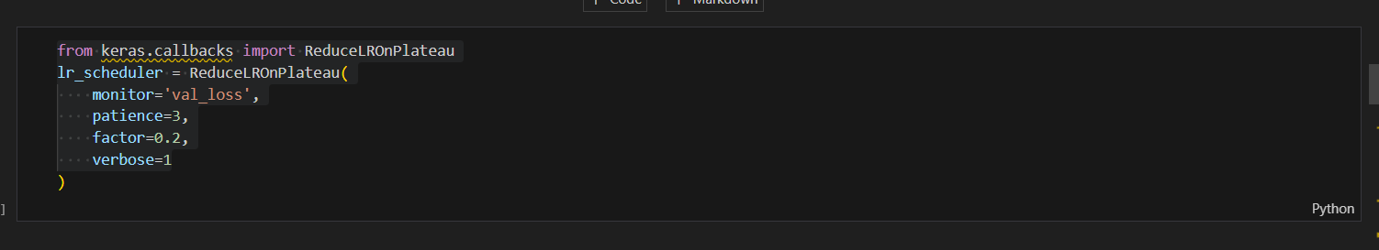

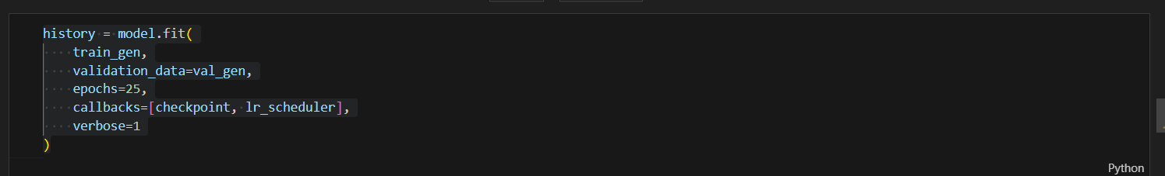

**Model Validation and Evaluation Report:**

|  |  |  |  |
| --- | --- | --- | --- |
| **Model** | **Classification Report** | **F1 Score** |  |
| VGG-16 |  | 95% |  |